BAND HANDBOOK 2023-2024

Stuart Tankesley  Director of Bands  stuart.tankesley@hsv-k12.org  256-428-8050 | Andrew Kirk  Associate Director of Bands  Andrew.kirk@hsv-k12.org  256-428-8050

Contents

Foreward | 14. Attendance Policy
- Mission Statement and Goals | 15. Chair Testing/Challenging Procedures
2. HHS Band Parent Association | 16. Policies & Procedures
3. Contact info; Who Should I Contact? | 17. Social Media Policy
4. Communication / Charms Information | 18. Band Room Expectations
5. Performing Ensembles | 19. Band Behavior Expectations
6. Marching Band Information | 20. Reinforcement/Punishment
7. Band Camps | 21. Grading Policy
8. Band Booster Dues | 22. Trip/Bus Policy
9. Instruments | 23. Additional Costs
10. Renting an instrument from HHS Band | 24. Individual Competitions
11. Property of HHS Band | 25. Private Lessons
12. Uniforms | 26. Student Leaders
13. Calendar | 27. Audience Etiquette
 | 28. Forms

Foreword

We are happy to have you as a member of the Huntsville High School Band Program! The program includes marching band, concert bands, jazz band, and other instrumental ensembles.
The band program at HHS strives to maintain a balanced effort in all facets of music education, including the development of the individual musician and superior ensemble performances. The tradition of excellence held by the HHS Band program developed through the hard work and dedication of past members and directors and is continued now through the hard work and dedication of our present director, staff and musicians like you!

This handbook is intended to guide all students and parents through their participation and experience in the band program, including what to do, what to expect, and what you must do to be successful and a contributing band member.

Being a band member means a shared musical experience with people you may know for the rest of your life. Your experiences in the HHS band will help you build character, aid in your academics, learn musicianship, and build relationships with your peers that last a lifetime. In addition to the music you will learn and experience, we strive to teach integrity, hard work, discipline, commitment, dedication, respect, time management, and team work.

Being a Band Parent means you are a partner in this experience with your student. You are connected to other parents in this organization through the Huntsville High School Band Parents Association. Active band parent participation is vital to the success of this organization. A parent’s presence, time, efforts, and financial support help our program provide students with the experience of a lifetime as a member of the Huntsville High School Band.

Please read this handbook carefully and refer to it as needed throughout the year. Every question may not be answered by this handbook. If there are any questions, please email a director or booster president!

Thank you for being a part of our organization!

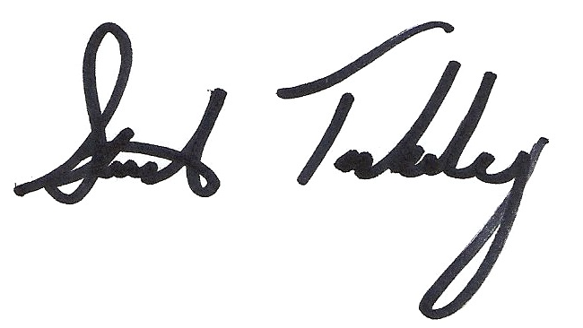

Stuart Tankesley
Director of Bands

1. Mission Statement and Goals

The HHS Band strives to serve the students, school, and community through the following goals:

- Represent yourself and your organization with class and show respect in your image and actions
- Present emotionally rewarding performances through individual and ensemble excellence
- Create competent citizens who are ready for college, the workforce, or military service through teamwork, responsibility, and musicality
- Hold yourself accountable in your preparation, performance, and reflection

2. HHS Band Parent Association
The HHS BPA is an organization of all parents/guardians of HHS band students. The sole purpose of this organization is to improve the well-being of the HHS Band program by using their time, talents, and treasures. Without the successful operation of this group, the HHS Band cannot exist. The following is what parents can do to support the HHS Band Parent Association:
1. Attend Band Booster Meetings. Schedule of meeting dates and times will be furnished on the band calendar. Meetings are normally on a Tuesday at 6:00 pm. The week of the meeting will be determined based on school and band events.
2. Volunteer for Booster Committees. There are many different tasks with which we need your assistance, and everyone can find the niche that suits them best: hospitality, chaperones, uniforms, publicity, sewing, Pit Crew (dads building and moving equipment, taking care of practice field), concessions and other special events. There will be a sign-up time at the Mandatory Band Camp Booster Meeting.
3. Be timely with your payments and forms. All of our board members are volunteers. Please help them by making sure you turn in your payments and forms to the band box in a timely manner.

3. Who to Contact

Title | Name | Email | Reason to contact
Director of Bands | Stuart Tankesley | stuart.tankesley@hsv-k12.org | Grades, rehearsal/performance conflicts, medical, parent concerns, etc
Associate Director of Bands | Andrew Kirk | Andrew.kirk@hsv-k12.org | Grades, rehearsal/performance conflicts, medical, parent concerns, percussion, etc
President | Kelly Parrish | Kelly_parrish@hotmail.com | General questions, Charms, spring trip, concerns regarding boosters and activities
1st Vice President (Volunteers) | Jaime Davis | Jaimedavis5@me.com | Contact to chaperone or volunteer; Brick Fundraiser
2nd Vice President (Fundraising) | Lisa Allport  Michelle McNabb | lisaallport@bellsouth.net  Mtmcnabb@bellsouth.net | Questions regarding fundraisers
Treasurers | Brenda Tapia  Christine Starnes | brendahtapia@gmail.com  christinestarnes19@gmail.com | All finance related questions.
Secretary | Joe Rist | Joemrist@gmail.com | Meeting minutes; Charms
Uniforms | Michele Vice  Kerri Thomas  Helena Johnson | Mspvice@yahoo.com  Thomas.kerri@yahoo.com  Johnsona72@yahoo.com | All uniform related issues
Communication/Media | Marvin Millar  Dave Anderson  Deanna Anderson | Marvin.millar@gmail.com  The.andersons4@gmail.com | Weekly Newsletter  website, facebook, social media
Hospitality | Kristina Hutcherson | Kristinahutcherson@gmail.com | Food-related issues / Banquet
Equipment/Trucks | Les Skulski | Leszek68@yahoo.com | Driving a truck/help loading
Color Guard Liaison | Pam Rogers | Rogers.pamela99@yahoo.com | Color Guard Questions
VBC Liaison |  |  | Sign up to work at the VBC
Trip Committee Chair | Karen Hansberger | Karen.hansberger@icloud.com | Coordinating Trips
Pit Crew | Michael Stahl | Stahlm@gmail.com | Coordinating Pit Crew
Photo coordinator and Senior night Coordinator | Kelly Parrish | Kelly.parrish@hotmail.com | group and individual photos

4. Communication / Charms

Our primary way of communication is through Charms. We also use Remind to communicate via text and our website, HuntsvilleHSBand.com and our remind service, contact the booster president to get on this service. We also post photos, videos, and successes of the group on our facebook page.

Charms
Charms is a web-based software that aids our program and makes access to your information very simple! EVERYONE in the HHS Band (students and parents) need to know how to access this information. If you have any questions, please email the booster president.

To access charms:

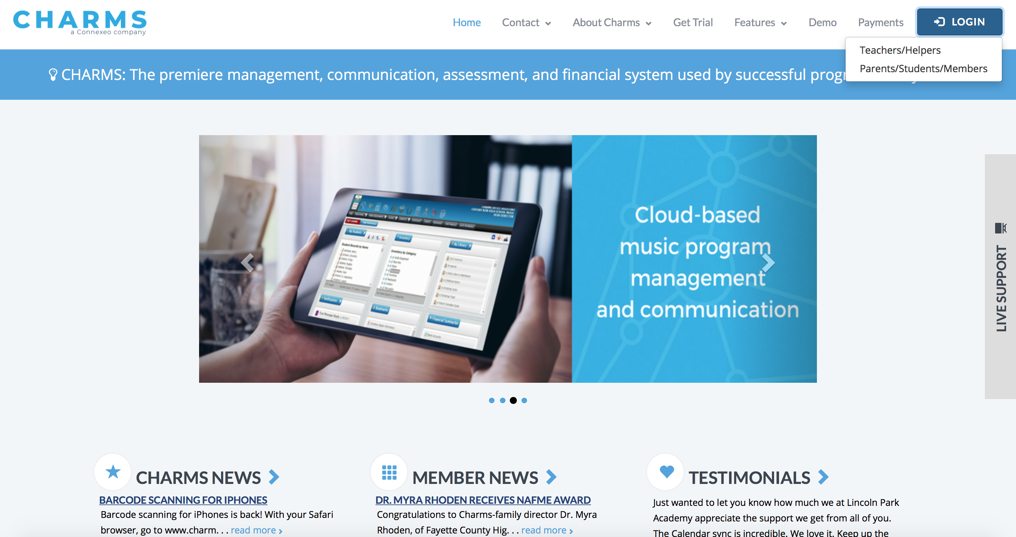
- Go to charmsoffice.com and move your mouse over the “Login” button at the top right. Click on Parents/Students/Members

2. Enter HuntsvilleHSBand as the school code and click to enter charms

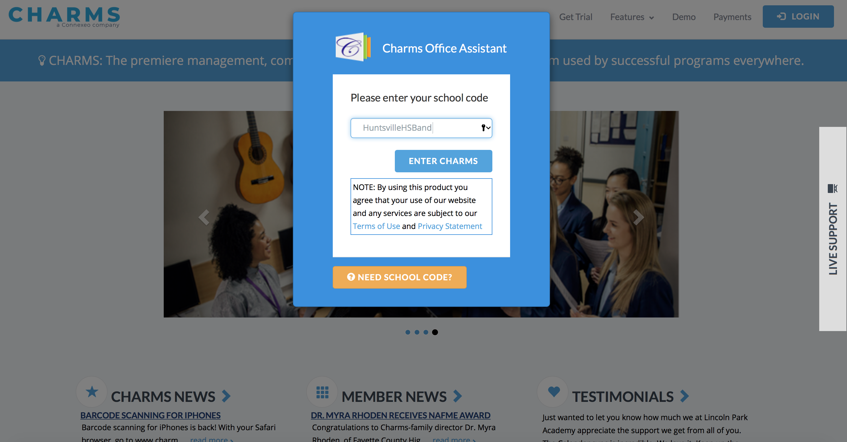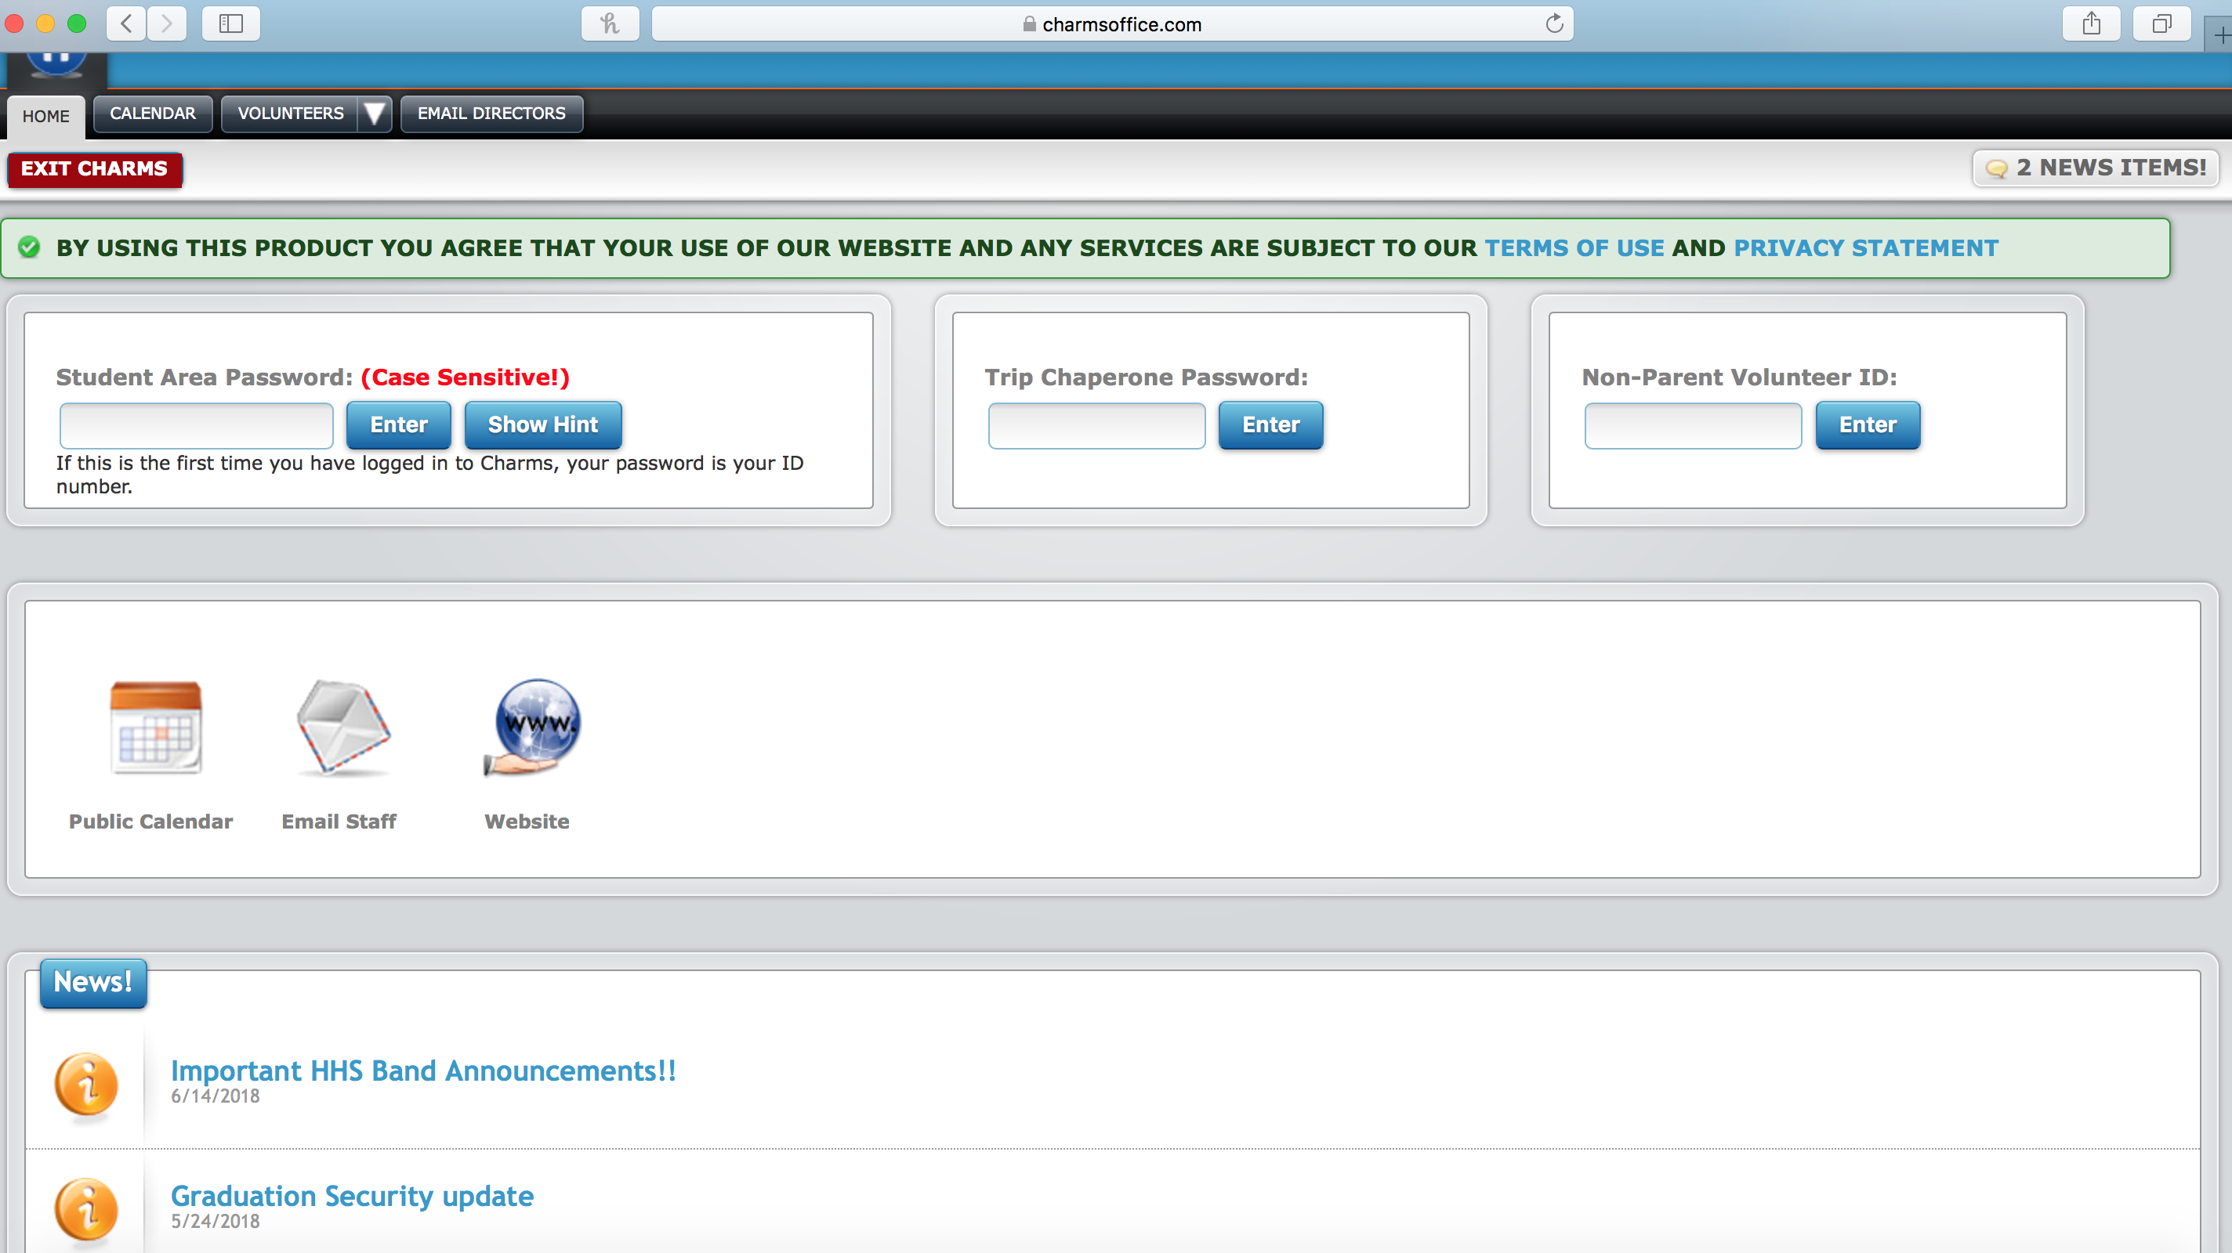 3. At this point you can access the public calendar, our website, and news (emails that have been sent out). The next step is to access your student’s account by entering your student area password. If you don’t know your password, you can enter 12345678 as your student id and it will prompt you to reset your password.

4. Once inside your student’s account, you should be able to see lots of icons including signing up to volunteer, handouts, finances (where you can view your account balance), and more!
The most important of these is the “update info” icon. Click this and check to see if your information is correct.

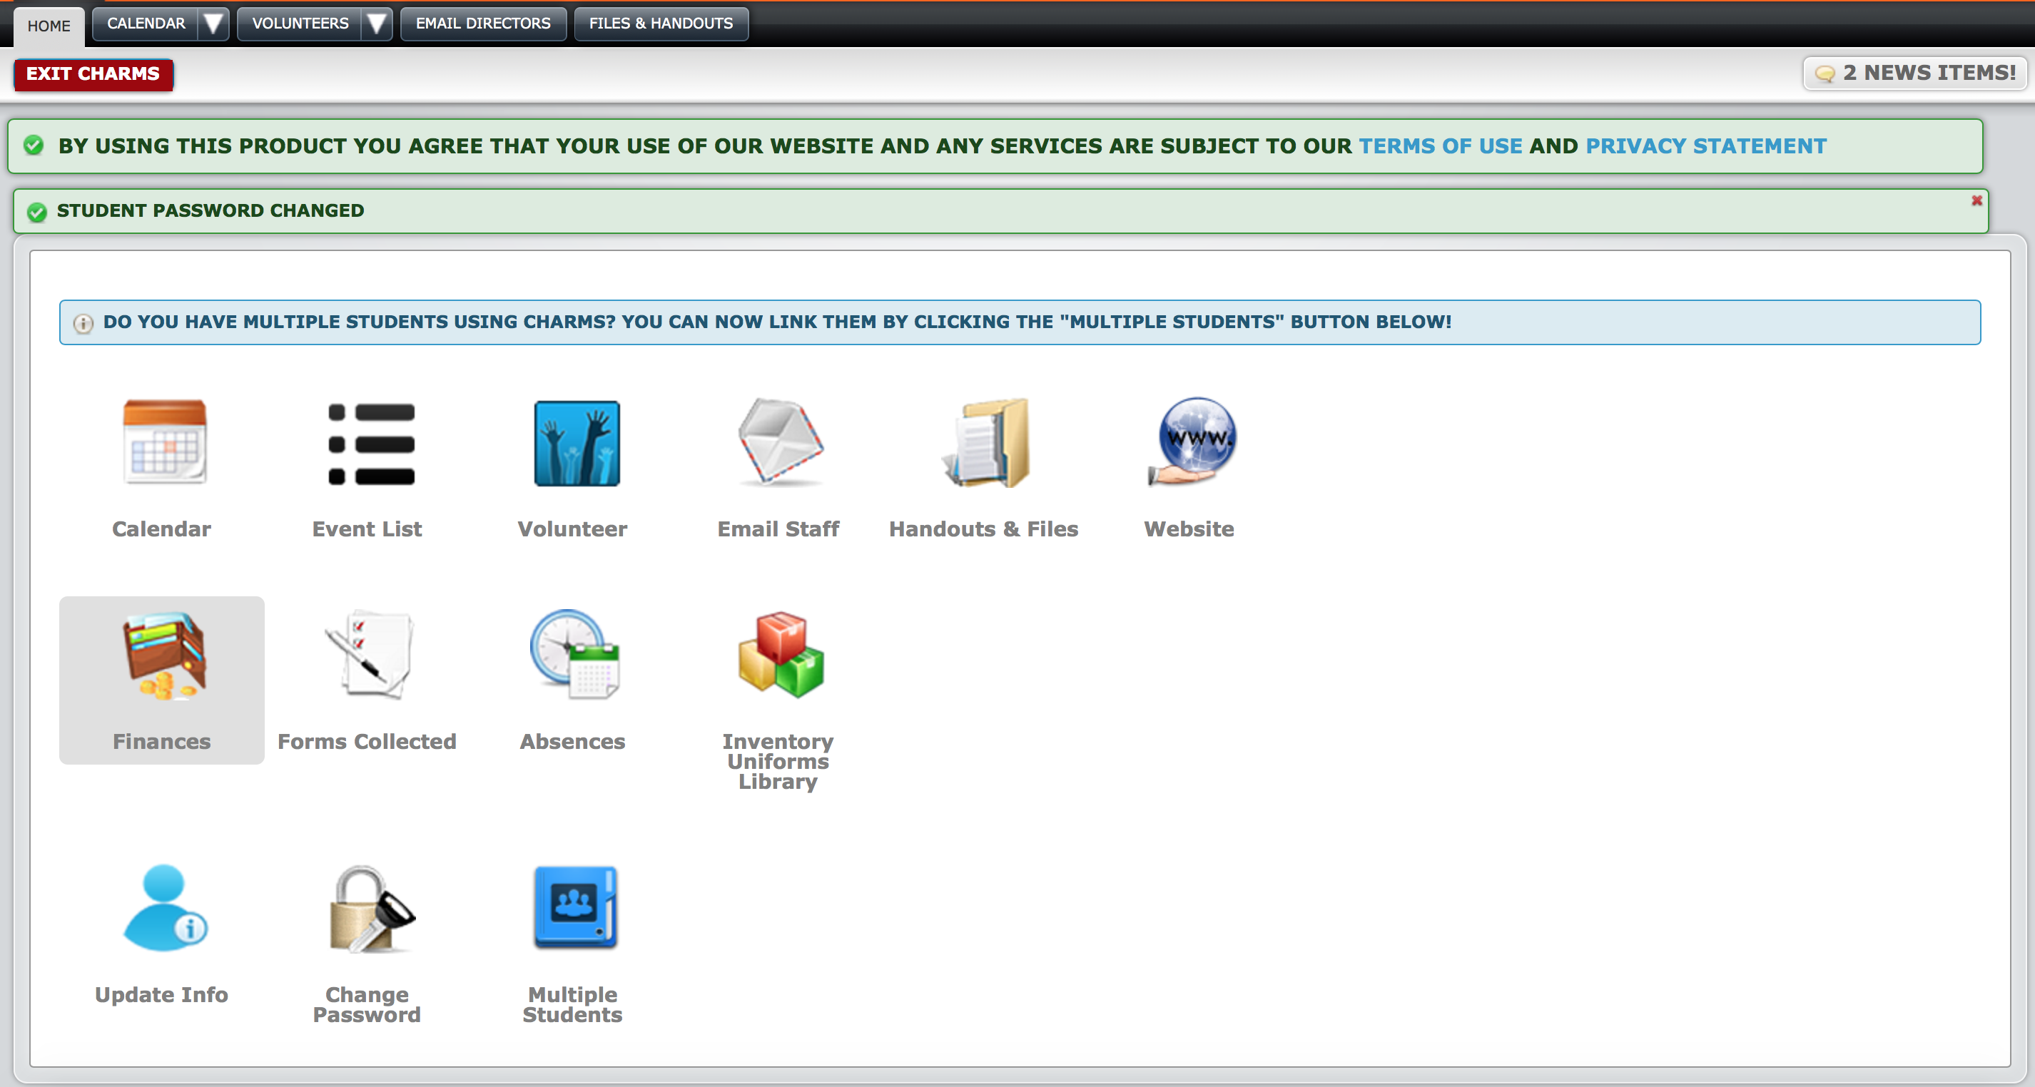
5. You should see this screen once you click “update information.” You should be able to update your information. It is critical this information be correct for your student. If your name is not listed at the bottom - click “add adult” and add your information. All emails that are entered will be sent our newsletter and communication!

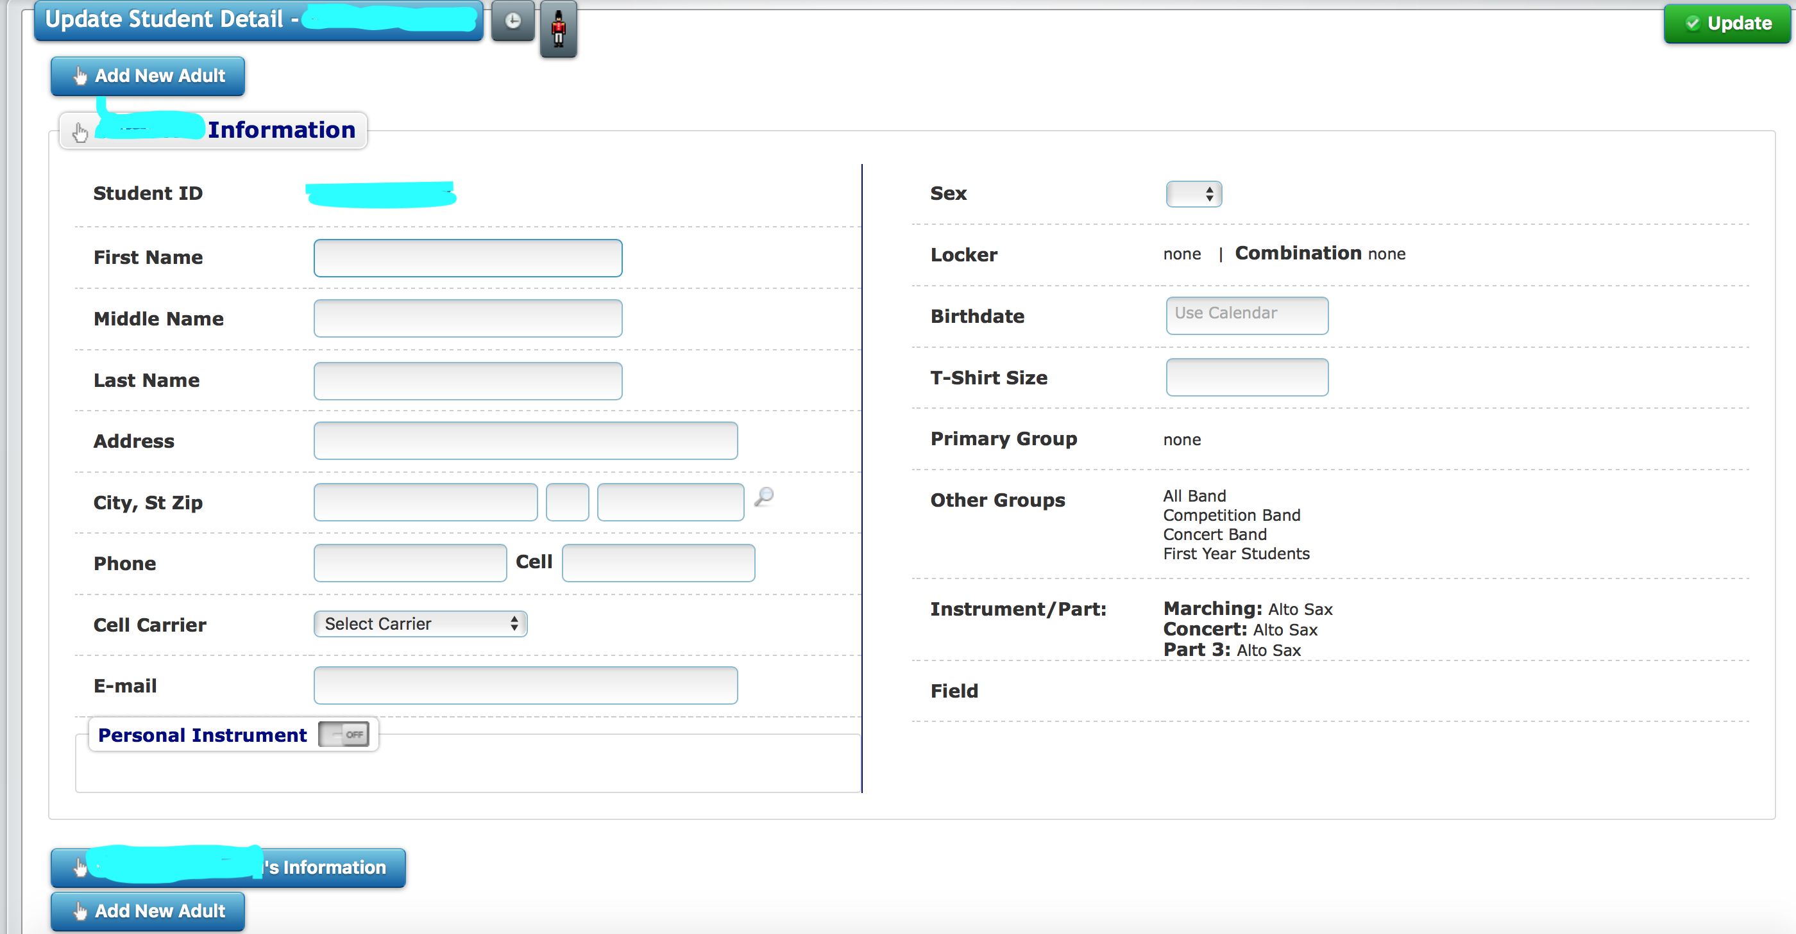
5. Performing Ensembles

All participants in the HHS Band Program are required to have successfully participated in a middle school band program or been accepted through auditions. Students who are in the band must be in the appropriate band class for both fall and spring semesters (except in extreme circumstances approved by the director). Students must participate in a concert ensemble. Competition Marching Band, Football Marching Band, Jazz Ensemble, and Chamber ensembles are encouraged, but not required.

Concert Ensembles
Students are placed in concert ensembles based on an audition. Currently, there are two competitive ensembles: Wind Ensemble and Symphonic Band, and a non- competitive ensemble: Concert Band. Students in these ensembles should expect to perform at concerts every per semester and will have the opportunity to participate in extracurricular trips at an additional cost.

Students in these ensembles are required to be at after school rehearsals as scheduled. This will count as part of your grade.

Competition Marching Band
Consists of instrumentalists and auxiliary visual performers. Competition marching band is an optional activity. Participants must sign a contract in the spring for the next fall that secures their spot in the marching band. This is done in order to plan for the next fall for music, drill, budget, etc.

All marching band members are required to be at rehearsal from 4:00-5:45 pm on Tuesdays and Thursdays. Auxiliaries and percussion will also have a rehearsal on Mondays from 4:00- 6:00 pm. If there is a Thursday night football game or other schedule issue, the Thursday rehearsal may be moved to Monday or Wednesday if necessary. Attendance at these rehearsals and performances is required and will figure into each student’s grade.

Competition marching band participates in all marching performances and rehearsals. Competition Band Members must be enrolled in a marching band class. Being a member of the competition marching band does not guarantee you a spot in the show.

Students receive PE credit for this class!

Auxiliary Visual Performers
Acts as part of the visual entertainment for the HHS marching band. Divisions can include color guard and majorettes. Auditions for these groups are held late in the spring semester. An audition fee will be assessed for each prospective member to cover instruction and judges’ compensation. No member is guaranteed a spot in the auxiliaries – each member must re-audition each year. All members will be responsible for the cost of their uniforms and any necessary accessories.

Jazz Band
A select auditioned group of students consisting, but not limited to, five saxophones, four trumpets, four trombones, guitar, string bass, drum set, and piano. This group has its own class time and/or an extracurricular time. An extra Jazz Band fee may be required for new music, equipment, instruments, uniforms, etc. Any festivals/competitions/trips that are taken by the jazz band must be funded by the members via fees or fundraisers. Jazz band will exist depending on the time schedule and ability to have regular rehearsals.

Chamber Ensembles
Chamber ensembles such as a brass quintet, woodwind quintet, trombone choir, sax quartet, etc. may be formed. These ensembles are also considered extracurricular. Students who are enrolled in three band classes must audition for All-State and either be a part of the jazz band or another chamber ensemble.

6. Marching Band

Marching band is a physical activity – in fact, competition band students enrolled in marching band class receive their PE credit for participating in band. Beyond the strenuous nature of performances, students should expect to stretch, jog, and do other calisthenic exercises. Students who may have a medical or other reason for not participating in these activities should notify the director.

To ensure a healthy marching band experience, follow these guidelines:

- Bring a large water jug every day
- Wear sunscreen
- Wear tennis shoes at all rehearsals
- Wear appropriate clothing for the sun. All students must always wear a shirt.
- Drink plenty of water all day long.
- Eat healthy and eat breakfast during band camp.
- Wear sunglasses and a hat.
- Wear white or a light colored shirt.
- Do some moderate exercising before band camp.

Not every person in the competition band will get to march halftime. If your student is not marching in the show, please keep the following in mind:

- They are still a full member of the Huntsville High School Band and will travel with us.
- They will be in uniform and perform in the stands, parades, and pregame.
- They will be integrated into the show in some way such as sound, props, or other.
- There is something they need to improve to get a full spot - marching, music, or behavior.

Football Games
- Do not wear hats in the stands or with your uniform. If it is cold, stocking caps, earmuffs, or something for warmth is permissible.
- There is to be no random playing of instruments at any time. Any section or solo cheers should be cleared with the director prior to the game.
- At home games, sit in your assigned section (away games and contests, seating will depend on the type of stands). Sit in your assigned section the entire game.
- No outsiders allowed in the band sections. This includes alumni, unless approved by the director.
- No eating or drinking (except water) in the band area unless approved by the director.

Our home games are located at Milton Frank Stadium and Alabama A&M University. Students are responsible for getting to and from these games. A school bus is not provided. For away games not at these locations, we provide a bus for travel.

7. Band Camps

Students are required to attend 2-3 weeks of band camp near the end of the summer break. First year marchers will participate in a Rookie Marching Camp to learn basic marching fundamentals. Percussion and auxiliary members will attend camps specifically for their sections. All Competition and Football marching band members will participate in band camp.

Participation in these camps is mandatory for any student wishing to be in marching band. Any student who does not attend every day of band camp may forfeit their spot in the marching band halftime show and will only perform if another member is not able to fulfill their responsibilities. Students may also be moved to football band. Please wait until the Huntsville City School Academic Calendar is released and Band Camp is scheduled before making any summer plans.

Students are also required to attend Winter Band Camp - held usually in January and February.

8. Band Booster Dues

Students who participate in the HHS Band are required to pay yearly band fees to cover operational costs of the band program. Students may also be encouraged to participate in fundraisers. The payment amounts and schedule are on as follows:

Winds & Percussion Students - $750
Color Guard Students - $750
Concert Season Only - $350
Sibling - $350

Fee payment schedule will be:

End of May/June Rookie Camp - First payment of a minimum of $250 due (Fees paid in full by this date receive a 5% discount)

Band Camp / First week of School - Second payment of $250 due

Fall Concert - 3rd Payment Due - Remaining balance

Any student who is not current with their fees may forfeit their full membership in the band. Late payments may put the student’s performance opportunities in jeopardy. Fees can be offset if students and/or parents participate in any of our fundraising opportunities. For some fundraisers, the profits will go directly into the student account; others will directly benefit the band budget.

We do not want financial problems to be an obstacle to students participating in the HHS Band Program. For students who truly need it, financial assistance is available. Students and families who actively participate in fundraising efforts, but are having difficulty with meeting financial obligations or a payment schedule should contact the Band Director, or the Band Booster President In fairness to all involved, there will be no financial aid for any family who is not fully participating in available fundraising activities.

9. Instruments

All students are expected to have a quality, working instrument. Horn movements at football games are not required and should be done at your own risk of damaging your instrument. It is encouraged to look into adding your student’s instrument to your home insurance policy. You should have a picture or record of the serial number on the instrument.

You are required to have all necessary accessories for your instrument such as ligatures, reeds, mouthpieces, valve oil, slide grease, cork grease, mutes, etc). Percussion is required to have a stick bag containing 2 pairs of yarn mallets, 1 pair of hard (rubber) mallets), concert (not marching) snare sticks, 1 pair of general timpani mallets, and a triangle beater. These items should be kept in your stick bag at all times. We also recommend labeling these items with your name/initials.

Instruments should be in one of the following places at all times:

- In your hand
- Lined up with your section (marching band)
- In it’s case
- In your band locker (and in it’s case)
- At home!

Purchasing an instrument
Purchasing an instrument can be a difficult decision and a major investment. The directors and many private teachers in the area are here to help. Please use these resources! Do not purchase a new or used instrument without running it by a director first – online websites such as Amazon, eBay, and Craigslist will offer “budget” instruments that are not intended for use by school band members. Used instruments are a great possibility, but some may have faulty parts or a questionable history. Although eBay and Craigslist can be a great place to buy an instrument, do not buy an instrument based on its “value” price. It is highly recommended that you also consult with a private teacher/professional musician of that instrument.

For suggestions of local music stores or online dealers, please ask a director.

10. Renting an instrument from HHS Band

HHS Band provides rental opportunities for exotic instruments that are rare, extremely expensive, or used exclusively for marching band. This typically includes percussion, tubas/sousaphones, mellophones, baritones, french horns, english horn, tenor saxophones, bari saxophones and bass clarinets.

(edited July 2020) All students who use a school–owned wind instrument (all instruments except percussion) are required to take your instrument to Southeastern musical services (3308 9th Ave SW) after your final use of the year to have it serviced. You are responsible for all costs at this visit to return it to acceptable playing condition. This applies to marching and concert instruments. The policy change is to incentivize taking care of your HHS band instrument.

Because percussionists typically share equipment, your rental fee will be $100 per semester to cover the cost of percussion repairs, sticks/mallets, and replacements.

All students must provide their own necessary accessories such as: Woodwinds: Reeds, ligature, cork grease, swab cloth, etc.; Brass: Mouthpiece, oils, greases, cleaning supplies; Percussion: Extra pairs of sticks/mallets.

11. Property of HHS Band

All instruments, equipment, and other property of HHS Band and their members should be treated as if it is your own. Students are not to touch instruments that do not belong to them unless asked, even if you are trying to “help” by moving an instrument (except with the director’s permission). Handling an instrument in an incorrect fashion can break it, even when handled with care and the best of intentions. If a student wishes to help percussionists, please make sure to ask how to hold/carry that instrument as to not damage it. Sousaphones, baritones, mellophones, horns, low reed instruments, double reed instruments, etc., should only be played and held by those who are renting that instrument.

If any student is caught mistreating equipment, they will be held accountable. If any student damages any equipment beyond normal wear, they will be responsible for repairing/replacing said equipment.

At no time should a non-HHS band student play your instrument during a performance, including but not limited to before, during, and after football games, concerts, etc. AT NO TIME SHOULD ANYONE OTHER THAN THE PERSON RENTING AN INSTRUMENT FROM HHS PLAY THAT INSTRUMENT, including, but not limited to, percussion.

12. Uniforms

Students will receive a marching jacket, pants (bibber), hat (Shako), and bag for marching season. Students will receive a concert tux jacket with pants or a dress for a concert uniform. Students will also be required to have a HHS Band polo. Each piece is numbered and assigned to your student and is tracked by the uniform coordinator. It is your responsibility to ensure the same numbered uniform assigned to your student is returned when requested.

Marching Band Uniforms
One of the most costly, and therefore, valuable, assets of the band is the marching band uniform. These uniforms give the band a consistent look if worn correctly. Uniforms must be dry cleaned throughout the school year and return dry-cleaned and in good condition as the end of marching season. Wilson’s Cleaner’s located on Whitesburg Dr and in Hampton Cove are the preferred cleaners since they have specific cleaning instructions on file and provide a discounted cleaning fee for marching and concert uniforms. You will need to tell them both uniforms are Huntsville High School Band Uniforms. If you do not clean your uniform and the uniform coordinator has to have it cleaned, there will be up to a $25 fee charged to your band account.

Students need to purchase gloves, long black socks (not ankle socks), and black shoes (purchased through the band program) for your marching uniform.

Students should treat these uniforms with respect and adhere by the following guidelines:

- Students will either be dressed in FULL uniform or in NO uniform. At no time is a student to be wearing only part of their uniform (bibbers without jacket, jacket unbuttoned/snapped, full uniform with sneakers, etc.) unless given instructions to do so by a director. Students are to change into and out of their uniform in a private setting (or as private as possible).

- The only removable items will be the hat and gloves, which will not be worn at all times. When a hat is not worn, it shall be carefully placed on the softest ground surface available upright, not upside-down resting on its top.

- FULL uniform consists of the following items: Band t-shirt as undershirt, undergarments and athletic or other shorts, hemmed bibbers, jacket with all buttons/snaps fastened, black calf-length socks (no ankle-length or “no-show”), black marching band shoes, and white gloves. Auxiliaries will receive their uniform guidelines from their sponsor.

- There is to be no face paint or body paint while in uniform, whether that is the casual uniform (t-shirt and khaki shorts) or formal band uniform. This also applies to concert uniforms.

- During extreme cold weather, options will be given concerning protection for your face, ears, neck, etc. as necessary. Extreme weather is not an excuse to break uniform policy – come prepared (hot or cold).

- Any time a uniform is not being worn it must be hung and stored properly – students who do not hang their uniform properly may be charged to have the uniform cleaned or replaced if damaged.

- In the unfortunate event that a uniform gets wet, DO NOT MACHINE DRY. Hang from separate hangers and blot (do NOT wipe) any bleeding colors with a wet cloth. Any uniform that is mistreated will be replaced by the student at the charge of $500.

- Uniforms will be dry-cleaned periodically throughout the year – and this is the student’s responsibility. Please make sure your uniform is in its correct place at all times.

- There is to be no spitting, cursing, or public displays of affection (kissing, holding hands, etc.) in uniform. This includes concert uniforms.

- There is to be no eating in uniform except approved dry foods (such as granola bars, etc.) and you should only drink water or other clear drinks when in uniform (Propel, Sprite, 7Up, etc.)

- There is to be no jewelry worn (except auxiliaries) unless mandated by religious beliefs or medical concerns; any students who may need this exception should inform Mr. Tankesley. This includes bracelets, earrings, etc.

- All uniform parts should only be worn by the student to which they have been issued. Parents, siblings, friends, other band members, etc. should not wear any uniform parts, including shakos.

- Hair should be worn up and put inside your shako.

Uniforms are inspected before every performance. Everything must be clean and in good repair. Students who do not comply with the uniform policy may not be allowed to participate in the designated activity and receive an unexcused absence. Students must return uniform by the deadline given. Students who do not return their uniform may have their grade reduced or lose privileges within the band program. Lost or broken items will be replaced at the student’s expense.

Wind Ensemble, Symphonic Band, and Concert Band Uniform

The following uniform will be required for concert band performance settings:

Males:
Tuxedo (coat and pants) - provided by HHS Band
White tuxedo shirt
Black bow tie - provided by HHS Band
Black vest/cummerbund - provided by HHS Band
Black calf-length dress socks
Black dress shoes (can use marching shoes if necessary)

Any student who wishes to wear their own tuxedo may do so, but it must be seen and approved by Mr. Tankesley to ensure that it matches the school-issued tuxes.

Females:
Long black formal dress- provided by HHS Band
Black hosiery
ALL BLACK dress shoes – closed toe, no heels/platforms over two inches

If you do not clean your uniform and the uniform coordinator has to have it cleaned, there will be a $20 fee charged to your band account.

13. Calendar

The calendar is located on charmsoffice.com To access go to the this website and enter the school code: “HuntsvilleHSBand”. If you need a printed out version of the calendar, please ask a director.

14. Attendance Policy

Band is one of the few activities in which the absence of one individual affects a performance in a detrimental way. All students must attend every minute of every rehearsal and performance with the exception of the below excused absences. It is the student’s responsibility to clear any absence or partial absence in advance with a director (not section leader, staff member, or booster).

Students who have an upcoming absence should turn in a written note or email to the band director from a parent indicating the date (and times if appropriate) of the absence and a clear understanding of why that student will be absent. This should be done at least a week in advance. A submission of a note/email does not guarantee an excused absence. Any issues will be brought to the student/parents attention prior to the conflict. Students who are absent from school due to illness are excused from rehearsal/performances. Students who are present at school are expected to be at after school rehearsal / performances unless give approval from a director.

Excused absences are defined as the following:
- Death in the immediate family
- Illness with doctor excuse
- Illness with parent note/email (1 per month)
- School-sponsored extracurricular activity
NOTE: STUDENTS MUST COMPARE ATHLETIC/ EXTRACURRICULAR ACTIVITY SCHEDULE WITH MR. TANKESLEY AS SOON AS THEY ARE RECEIVED TO WORK OUT CONFLICTS.
If students have conflicts with school-sponsored activities, they will use the following guidelines: Game/Meet/Concert/Competition will be attended over practice/rehearsal. A school-related conflict does not automatically mean you are excused - a conversation with a director is necessary in advance to work out a plan.

Any time there is an activity/event that will cause any student of the band to be absent (Field Trips, etc.), please let Mr. Tankesley know as soon as possible so that alternate arrangements can be made.

The following are examples of unexcused absences:
      - Not having a ride
      - Having to work. This is a school activity and your employer is expected to work around your band schedule.
      - Studying for a test/finishing homework
      - Vacation
      - Non-school sponsored extracurricular activity (Little League, Dance Recitals, Club Sports, etc.)
      - Regular church services (rehearsals/performances will never go past 5:00 on Wednesday and Never on Sunday)
      - Not getting an absence approved prior to the rehearsal/performance.

Students who have an unexcused absence will receive a 0 for their weekly band grade. In addition, they are subject to removal from the next performance. Multiple unexcused absences may be subject to removal for the ensemble or the band program.

Students who have an unexcused absence from a performance will receive a 0 for that performance (test grade). Additional punishments such as removal from the ensemble or program as determined by the director may occur.

Tardies:
Rehearsal begins at the time as indicated on the calendar. Students that do not have their equipment, music, and accessories ready to go at the start of rehearsal are considered tardy.
3 unexcused tardies = 1 unexcused absence. Excessive tardies may result in removal from the ensemble or band.

The Bottom Line to Attendance:
Communicate! When in doubt, communicate well in advance your conflict. When you do this, it shows you have planned ahead to try and work a conflict out. Letting a director know the day of or the day before a conflict does not show a plan to work out a conflict. Show your commitment to this organization. It is never ok to just not show up for a rehearsal. The preferred method of communication is email: stuart.tankesley@hsv-k12.org

15. Chair Testing/Challenging Procedures

At the end of each semester, students will audition as part of their performance grade (usually a semester/final exam) as well as their chair placement for the following semester.

If a student is unhappy with their chair placement within a band, they may propose a challenge against the student one chair above them. If a student does not show up for a challenge, they forfeit the challenge.

A student can challenge an unlimited number of times until they are sitting first chair until a challenge is lost. The musical opinion of the directors will be the FINAL decision.

Challenges are meant to increase individual playing. If at any time the process of challenging becomes detrimental to the band program as a whole, the director reserves the right to discontinue its use.

16. Policies and Procedures

- Band members are expected to behave properly at all times. Discipline is a quality that must come from the individual. Each student is responsible for his/her own actions. Any students who shows an inability to work effectively in class may be re-assigned to another class.
- Misbehavior reflects poorly on the band, school, and community.
- Students are expected to demonstrate knowledge of the policies of the Band Program by their proper behavior.
- Ignorance of Policies will not be accepted as an excuse for misbehavior.
- Every effort is made to provide Policies. However, directors and chaperones may find it necessary to add to or alter Policies. These may or may not be in writing as the situation allows.
- Policies and directions delivered verbally should be considered the same as a written Policy

Consequences for failure to follow rules and policies may include the following dependent upon severity of infraction:
- Band Detention or band room service
- Lowering of grade
- Suspension from performances and/or band activities.
- Loss of performing position
- Move to another ensemble
- Removal from the band program
- School / Administrator assigned punishment

Any student who receives a school discipline-related suspension (on or off campus) may also have consequences within the band program. Students who spend an academic class day suspended (on or off campus) are not allowed to attend extracurricular activities on that day and will be asked to complete an alternate assignment for that day.

17. Social Media Policy

Students are expected to represent themselves in a positive way inside and outside of school. You represent the band program and the band represents you at all times. This includes social media. There is no tolerance for bullying (including social media), illegal activities, or immoral activities. These are subject to immediate dismissal from the band.

The Huntsville High School Band Facebook and other social media pages are designed to feature the positive things our program and students are doing for the band. It is the best interest of the program that comments not meeting this standard be removed.

18. General Band Room Expectations

        - Only band students should be in the band room.
        - No running, horse-play, or doing anything that could possibly damage equipment in the room.
        - Keep your band locker clean and organized.
        - You must ask permission to use a practice room. Practice rooms are used only for practicing.
        - The storage room is used only to store instruments. It is not a hang-out area.
        - Stay out of the uniform room unless you have permission to be there.
        - No eating or drinking (except water) in the band room unless permission is granted by a director.
        - Respect the band room and all the equipment.
        - Bad language will not be tolerated.
        - Do not store school books, projects, and papers in the band room.
        - Pick up after yourself and help keep the band room clean by picking up loose trash.

19. Band Behavior Expectations

Following these guidelines will ensure an excellent experience and excellent grade in band:

- Be on Time - Each student is expected to be on time. Students are expected to arrive early so they can begin rehearsal on time (as listed in the charms calendar). “To be on time is to be late.”
- Attend all rehearsals with a positive, disciplined attitude. Unnecessary talking will not be tolerated during rehearsals. Whether or not the director is directing information to you, you should pay attention because in some way it applies to you. Every member must know what’s going on. Follow all expectations outlined in the band handbook.
- Attend all games, competitions, parades, and performances.
- Retain and maintain all distributed materials (music, uniforms, etc). Students should have a working instrument, music, dot book (marching), accessories, and a pencil (not ink pen) ready at every rehearsal.
- Perform all music and visual (marching band) aspects to the best of your ability.
- Communicate participation conflicts with a director in a timely manner.
- Pursue self and group improvement at every opportunity
- Pass all classes.
- Don’t have your cell phone out during rehearsal unless specifically granted permission from a director.
- Respect all directors, adult staff, guests, chaperones, and students.

For daily classes, class begins three minutes after the tardy bell rings. This means that you are in your seat with your instrument, a music stand, your music, and a pencil warming up for the day's rehearsal. Make sure you have extra reeds, mutes, oil, etc. During warm-up time, percussionists will be setting up all needed equipment for the rehearsal and studying your music quietly.

Attitude
Those students who have a positive mental attitude, regardless of their individual skills, will always have a place in the band. Regardless of your ability, if your attitude is not positive and you are not doing your personal best to make the group successful, you should not be a part of this organization. In fact, students who do not project an attitude that is positive and cooperative will be given the opportunity to change their personal perspective or else leave the organization. Those who have pride in themselves will generally project a positive mental attitude. Characteristics of a positive mental attitude include a generally cheerful outlook toward rehearsals and performances, cooperation in the preparation and maintenance of equipment and facilities, and an eagerness to do what is necessary to be successful. In short, the total band member is someone who is always willing to give his or her best for the good of the organization.

20. Reinforcement and punishment by Staff and Student Leaders.

- It is the tradition of the Huntsville High School Band to use physical skill sets as a way to reinforce positive and negative aspects of marching band. Students may give themselves one of these skill sets as a way to reinforce concentration and excellence. However that should not take away from, or disrupt the rehearsal. A standard reinforcement would be 10 pushups.

- Student leaders may deem it necessary to give reinforcement information at times, but should always do so with careful consideration. A standard reinforcement is 10 pushups or run 1 lap.

- Staff members may deem it necessary to give reinforcement information at times, but do so with careful consideration. It is considered acceptable to give 1 lap, or a set of 10 pushups, or a set of 25 sit-ups, or a set of 50 jumping jacks as a result of this reinforcement. However, students may be assigned more than 1 lap to run if deemed necessary by the band director(s).

● Students who feel they are being pushed beyond their ability to maintain a personal safety level of physical exercise should stop immediately. They will not be punished for being unable to complete the physical skill set that is being required of them. Alternative reinforcements can and will be found to alleviate the unsafe situation. They should communicate this to an adult.

21. Grading Policy

In determining the band grade each 9-weeks, 2 areas comprise the average:

- Performance Grades - typically includes class assignments, section rehearsal assignments, chair tests, quizzes, pass-offs, and written assignments.
- Participation Grades - including having music, instrument, and a pencil at every rehearsal. Correct marking of music, care and maintenance of instruments, punctuality to rehearsals and performances, attendance at rehearsals and performances, uniform turn-in, distractions (cell phones, talking, etc), instrument taken home every day.

Each class day, a member’s daily grade is determined by his/her class participation.
Students are expected to have a working instrument, music and class materials for all
classes. Occasionally students will be asked to do an assignment that will be
used as a double grade. Grading percentages may also be contingent
upon campus guidelines.

22. Bus/Trip Policies

- All Huntsville City Schools and HHS Band policies must be followed while on buses or trips.
- Students are expected to show respect for and follow any instructions given by directors, chaperones, or bus drivers.
- Students are expected to represent themselves, the HHS Band, HHS, and Huntsville in a positive way on the trip. As in any situation, good judgment must always prevail.
- Mixed company in hotel rooms is prohibited.
- Students must always remain seated and use a conversational voice on the bus. Playing music requires you to have ear buds.
- Members must remain reasonably quiet at all times when in hotel facilities. Curfews will be strictly observed. Any personal needs which might require leaving your room after curfew, must be arranged in advance with a chaperone or director.
- Additional rules and regulations may be added based on the location of the trip.
- Bad language will not be tolerated
- Any major violation of rules (as determined by a director) may require a student to be sent home. This will be at the expense of the parent and may include the students and a chaperone.

23. Additional Costs

In addition to the band fees there may be additional costs to the band program that include Band Banquet tickets, Meals, Spirit Wear, Spring/International Trip, Performance Tickets, Private Lessons, Individual Competitions, and Camp dues.

24. Individual Competitions/Performances

The Huntsville High School Band strongly encourages individuals to participate in festivals and competitions that are done on an individual basis. These events make you a stronger musician and you receive a great experience. Some of these include District Honor Band, All-State, Solo and Ensemble, State Solo Competition, College Honor Bands, and other regional/national honor bands.

All District and All State Auditions typically happen at the end of January and music is given out in September!

If you are interested in participating in a honor band and not sure where to start, speak to a band director! Most colleges and universities host an honor band.

There is typically a cost associated with most of these that the individual must pay. For most of these events, students are responsible for transportation and hotel (when appropriate). To be eligible for these auditions/events, students must be in good standing with the Huntsville High School program as determined by the director.

25. Private Lessons

Private lessons are the key to developing an outstanding musical organization. Students who study their instruments privately with a professional instructor show rapid improvement in individual musicianship. As these students improve, their excitement towards practicing increases, they continue to improve, and they become a stronger contributor to the overall success of the band. Most students in the wind ensemble study privately.

Private instruction has a great impact on the individual student and on our band program both this year and in the future. Directors will assist you, if needed, in selecting a private instructor.

26. Student Leaders

The HHS Band Leadership team is a group of student leaders that work with the director in an advisory capacity. The students will also be called on for special presentations to accept awards, do interviews, have pictures taken with political representatives, etc on behalf of the band. The student leadership team is made up of the Band Captain, Drum Major, Guard Captains, Percussion Captains, Section leaders, Librarians, Truck/Equipment captains, and other student leaders. To be eligible for an office, candidates must be full participants in the band program, exemplary in attitude, loyalty, dedication, and willing to give of their personal time for the betterment of the Band. One of the primary assignments of all student leaders will be the Band’s morale.

Directors and staff are always looking for student leaders for the future of the program. Students who are interested in become part of the leadership team go through a vetting process in April or May for the following school year.

4 Things you should know about our student leaders:

- All student leaders will carry out the policies of the Band, Band Director, School, and School Administrators to the best of their abilities.
- Section leaders are an extension of the band director’s authority. Any time you question or disagree with specific instructions from a student leader, please avoid confrontation and discuss the problem with the director at your earliest convenience.
- Student leaders cannot give you permission to miss a rehearsal or performance, be tardy, or leave early.
- Student leaders should be positive and work for the best interest of the Band at all times.

27. Audience Etiquette

- Always be encouraging of other groups. Every group has a different situation. Never say anything negative about another ensemble (concert or marching). Be a class act.
- Always wait until the end of a performance to leave your seat. This includes marching band competitions.
- Never be on your cell phone during a performance.
- Give the performers the respect you would want given to you after all the hard work that you did!
- Do not talk or be disruptive during a performance.

Media Usage Form

The Huntsville High School Band has many media outlets to positively promote our program. The most visible of these include our facebook page and our website.

If you would not like your students face or name included in any of this media, you have the opportunity to opt out by checking the box below and submitting this form. Please feel free to discuss your wishes regarding your student with our media coordinator (see list at the top of the handbook).

[ ] Please check this box if you do not wish for your student’s name or face to be included in any media outlets. The student may be photographed or recorded via video, but their name and/or face will not be included or will be blurred if necessary.

____________________________________ Student Name

____________________________________ Parent/Guardian Name(s)(Print)

____________________________________ Parent/Guardian Signature(s)

Huntsville City Schools
Out of County/Overnight Student Trip/Event Medical Release Form
Student’s Name: |  |  |  |  |  |  |  |  |  | Date of Birth:
Street Address: |  |  |  |  |  |  |  |  |  | City:
Parent/Guardian #1 |  |  |  |  |  |  |  |  | Parent/Guardian #2
Address: |  |  |  |  |  |  |  |  | Address:
Home Phone #: |  |  |  |  |  |  |  |  | Home Phone #:
Phone # @ Work: |  |  |  |  |  |  |  |  | Phone # @ Work:
Employer: |  |  |  |  |  |  |  |  | Employer:
Cell Ph. # or Pager: |  |  |  |  |  |  |  |  | Cell Ph. # or Pager:
Health Insurance: |  |  |  |  |  |  |  |  | Effective Date:
Contract Number: |  |  |  |  |  |  |  |  | Group Number:
If unable to reach parent/guardian, please notify:
Name: |  |  |  |  |  |  |  |  | Relationship
Home Ph. #: |  |  |  |  |  |  |  |  | Cell Ph. # or Pager:
Student’s General Health Information
1. | List your child’s daily medications: (doses and times of administration)
 | (1)
 | (2)
 | (3)
 | (4)
2. | List any Emergency and PRN medications OTC or prescribed for your child and the
 | circumstances under which they are to be given.
 | (1)
 | (2)
 | (3)
Yes No A completed and signed School Medication Prescriber/Parent Authorization Form (PPA) is required
for each medication –prescription or over-the-counter (OTC) is on file at school?
3. | List student’s health conditions requiring procedures or medication; i.e. Asthma,
 | Environmental, Seasonal Food allergies (Be specific), Diabetes, Seizures, etc.
 | (1)
 | (2)
 | (3)
4. | An Individual Health Care Plan (IHP) is on file at school |  |  |  |  |  |  |  |  |  | Yes |  |  | No
 | List IHP(s):
 | Family Physician:
 | Address: |  |  |  |  |  |  |  |  |  |  | Phone:
 | City: |  |  |  |  |  | State: |  |  |  |  | Zip Code:
I give permission for an adult representative for Huntsville City Schools to authorize emergency medical
treatment and give reasonable necessary medical decisions my son/daughter may need while participating
in the student event/trip(s).
Signature of Parent/Guardian |  |  |  |  |  |  |  |  | Date:

HUNTSVILLE HIGH SCHOOL BAND
Medical Consent Form Year:______
Name of Student: ______________________________ Age: ________ Grade:______
Home Address: _________________________________________________________
MothersName:______________________Home#______________Work#___________
Fathers Name: ______________________ Home #____________ Work#___________

Designate two adults to be contacted if a parent or guardian cannot be reached:
Name: ___________________________ Phone: _____________Relation:___________
Name___________________________ Phone: _____________Relation:___________

Student’s Physician: _________________________ Phone: _____________________

Provide the following information on at least one hospital/medical insurance:

Name of Company: ______________________ Insured Name:_________________ Group/
Member No: ____________________ Policy No: ___________________
Contact Lenses? Yes____ No_____ Date Last Tetanus Shot: ___________

Does student have any known medical problems or allergies? If yes, list:

Does student take any medications on a regular basis? If yes, list:

Is student allergic to any medications? If yes, list:

Any other special instructions for care to be given student?

NEITHER HUNTSVILLE HIGH SCHOOL NOR HUNTSVILLE HIGH BAND PARENTS, EITHER INDIVIDUALLY OR COLLECTIVELY, ASSUMES ANY LEGAL RESPONSIBILITY FOR ANY ACCIDENTS OCCURRING WHILE STUDENTS ARE PARTICIPATING IN SCHOOL SPONSORED ACTIVITIES.

I hereby give my permission for the above named student to participate in Huntsville High Band Activities for school year _________.
Yes ____ No ___
I further give permission for the student to be taken to the nearest clinic or emergency room for treatment by a licensed physician.
Yes ____ No ___

Signature of Parent or Legal Guardian: ____________________________________
Date: ______________________

Handbook Agreement Form

By signing below you are acknowledging:

You understand the band policies as outlined by the handbook.

I give your student permission to participate in the fundraisers for the band, which include but not limited to VBC Concessions, Mattress Fundraiser, Letter campaign, Boston Butts, and Bed Sheets.

You give your student permission to travel with the band to football games, competitions, concerts, and other performances. This is a blanket field trip permission.

____________________________________ Student Signature

____________________________________ Student Name (Printed)

____________________________________ Date Signed

____________________________________ Parent/Guardian Signature

____________________________________ Parent/Guardian Name(Printed)

____________________________________ Date Signed

Students may not participate in band without this form completed.

