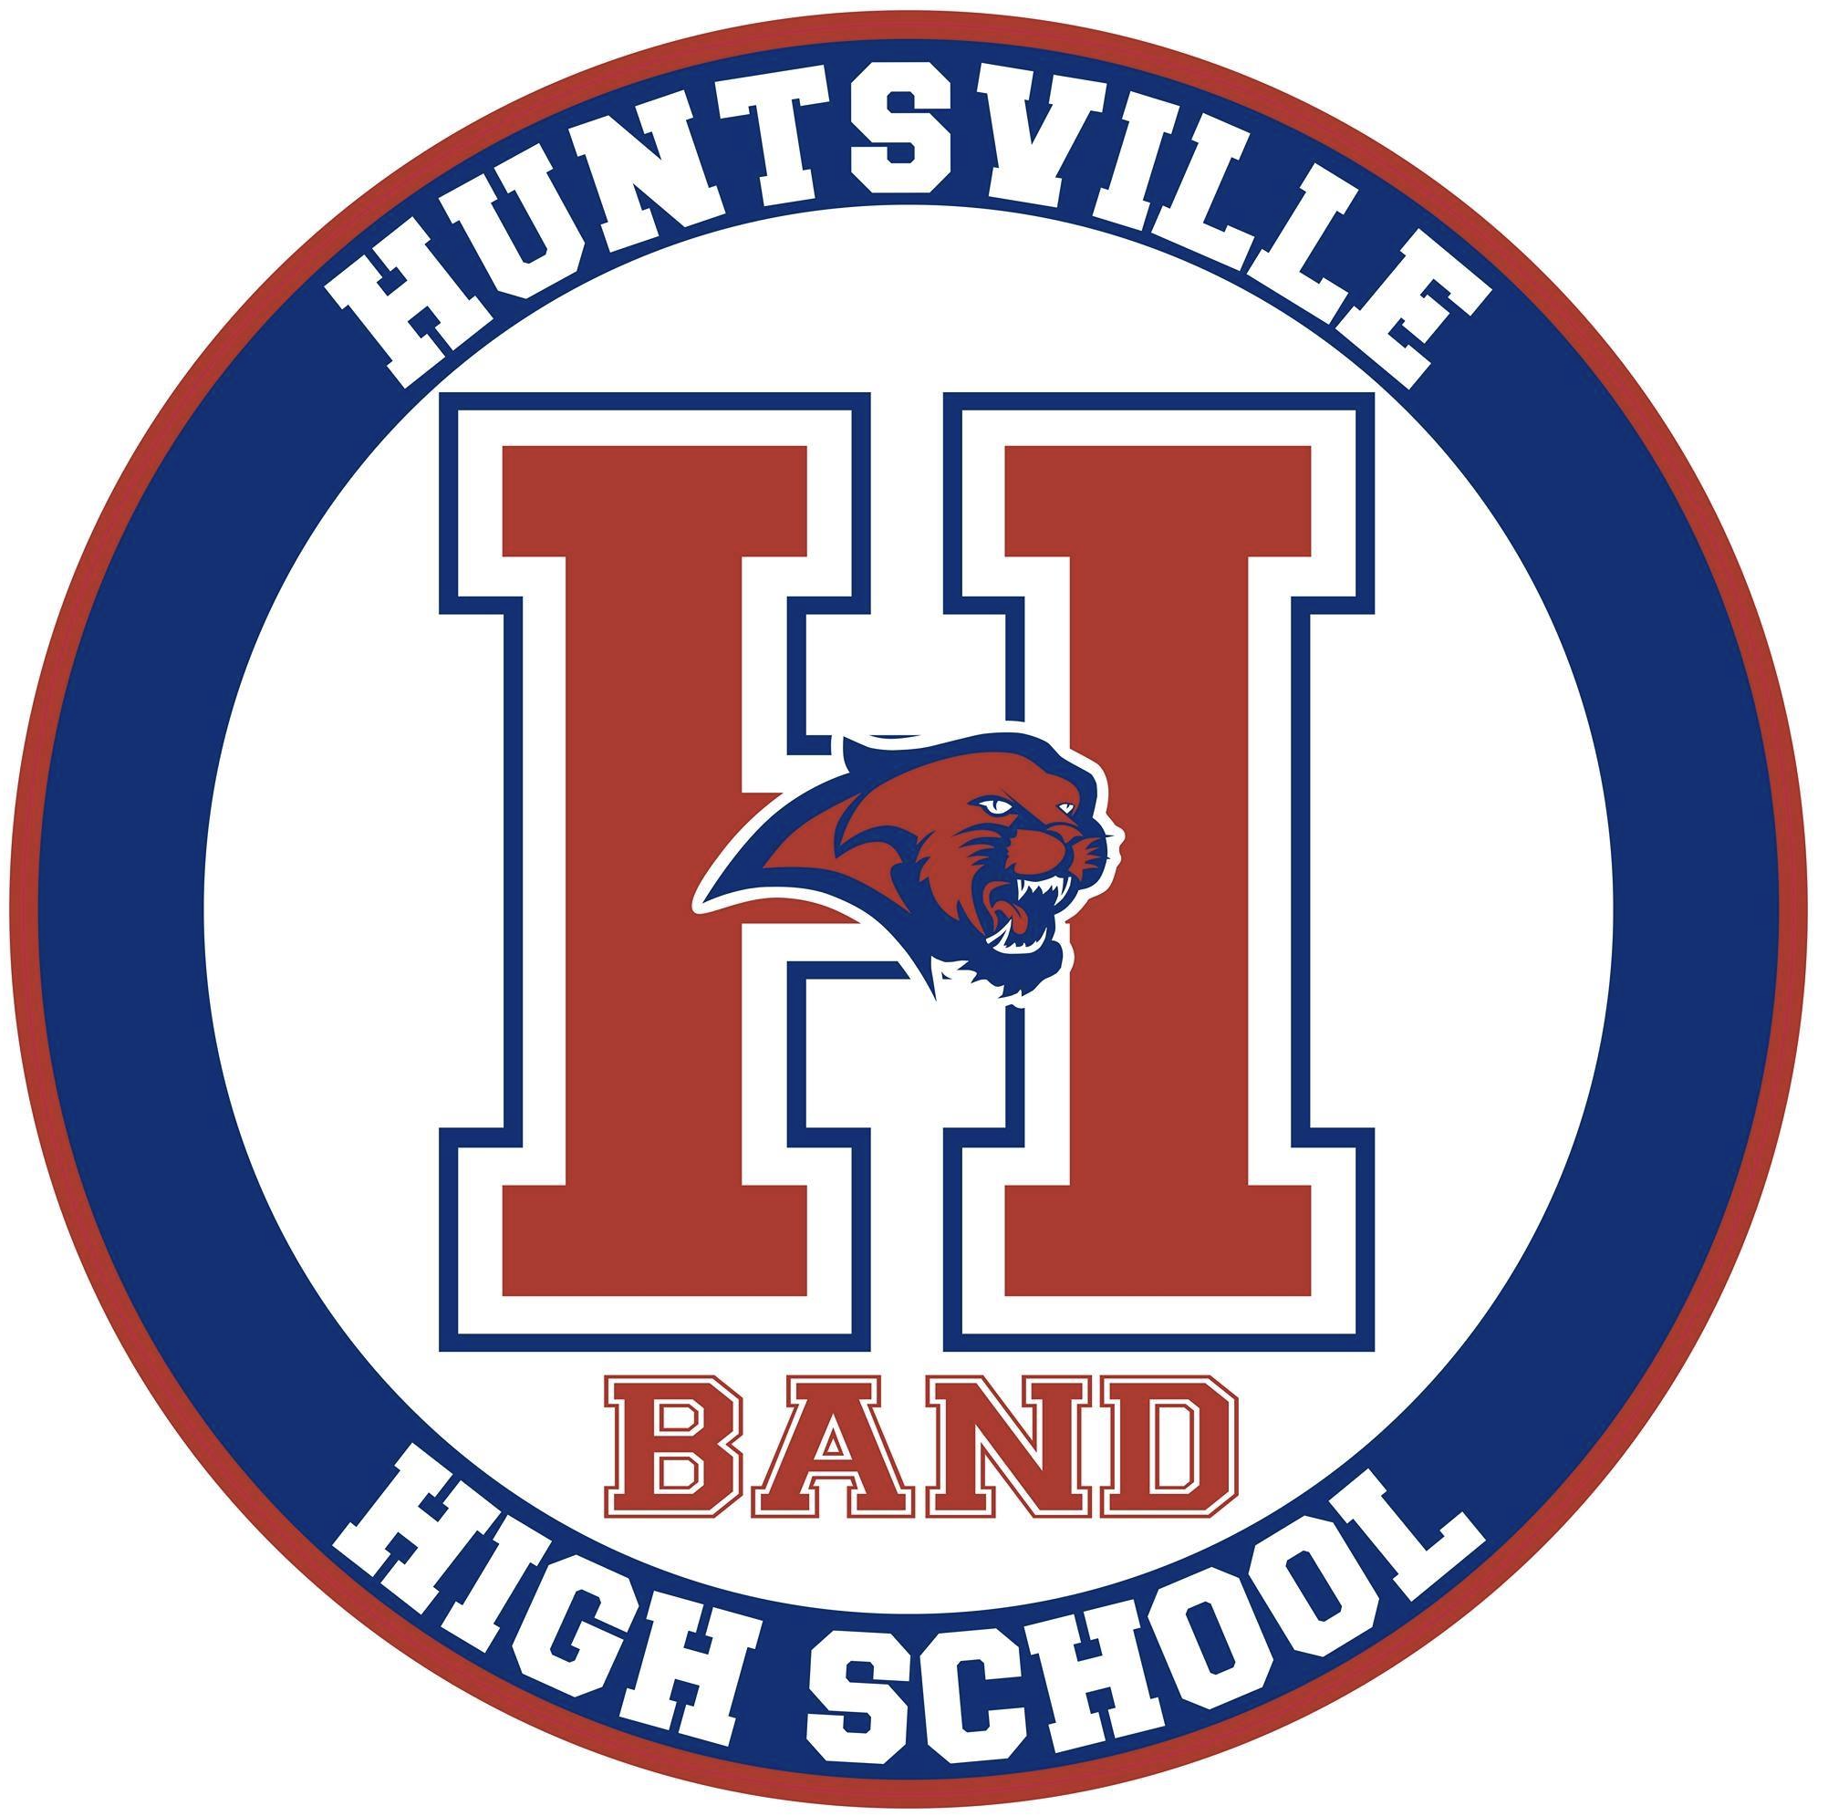
Huntsville High School Band Parent Association
Board Meeting Minutes
January 12, 2021
- Call to order
BPA President, Darin Miller brought the meeting to order by zoom call at 7:00 pm on Tuesday, January 12, 2021.
There were a total of 12 board and committee members and many parents present by zoom.
- Overview and general discussions
  - Darin Miller opened our meeting and asked if there were any questions or corrections to the posted board minutes from our December meeting. Being that there were none the minutes were approved as written.
  - Darin Miller welcomed parents to the meeting. Mentioned that he wanted to make sure everyone is receiving our newsletter each week. He gave a budget review at a glance. We are running ahead of budget by about 3K. We have some large fundraisers coming up. They will be vitally important. He encouraged everyone to work at the VBC; there will be wristband trainings coming up.
  - Stuart Tankesley talked about winter band camp that will be held in February. The dates are Feb. 4th from 4:00-9:00, Feb. 5th all day and there will be a boxed dinner, Feb. 6th there will be a rehearsal in the morning and a concert at 11:00. Mr. Denton from Chattanooga will work with Wind Ensemble and Lisa Burton will work with Symphonic band. He continues to encourage kids to follow school regulations as r as social distancing. MPA is still scheduled for March, but it may be virtual. All state auditions will be virtual and start this week. District Honor band will be late April or early May.
  - Elena Barbre gave us a fundraising update. Sheet sales are complete and the band earned around $1600. The mattress fundraiser is coming up on February 27th. We have a local church that is willing to host if needed. Advertising for brick sales is coming up.
  - Darrin Miller asked us to start promoting the mattress fundraiser. We talked about ways we could do this. Panther Postings, Signs, Social Media, possibly videos are several ideas. The target dollar amount we would love to raise is $4100. Next month we need to form the nominations committee. Update on the bond. We should have that complete in the next week and it will be good for 3 years.
  - Marcia Flatau updated everyone that color guard. The upcoming winter guard competition dates are February 6th and 20th also March 6th and 20th. There may be a local one in February at Bob Jones. Will share details as soon as they have them.
  - Kirk Wimsett gave us a truck update. Would like to take the percussion truck in before MPA and then have the equipment truck oil changed in late spring or early summer. Going in to next year he will be looking for someone to take over this role.
  - Kim Ejede mentioned the dinner that will be provided to students during winter band camp. This will be on Thursday, February 4th. She will send out a Google doc for kids to sign up. She will also need a few volunteers to help with this. 4-5 parents should be plenty.
- Adjournment
Meeting ended at 7:28 pm by BPA President, Darin Miller.

Minutes submitted by: Kelly J. Hudson
Minutes approved by: ____________________ Date:___________________________

