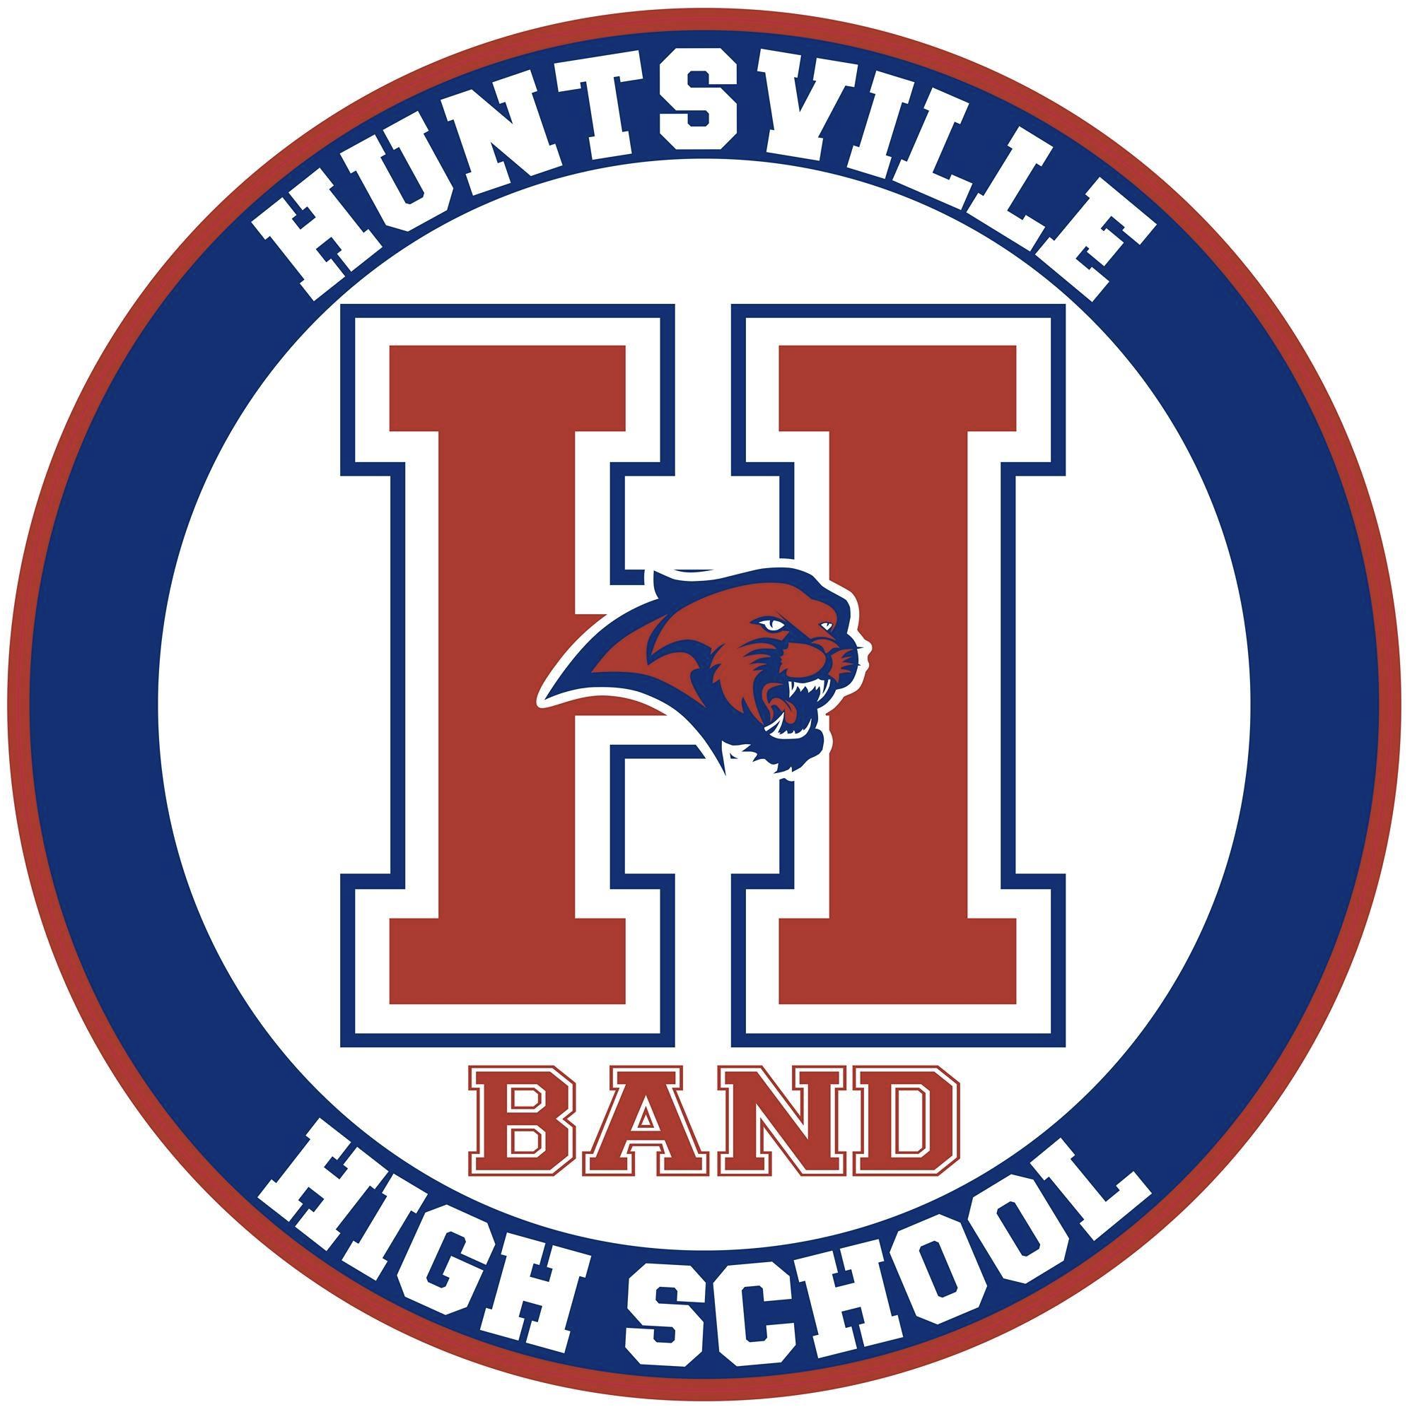
Huntsville High School Band Parent Association
Board Meeting Minutes
November 10, 2020
- Call to order
BPA President, Darin Miller brought the meeting to order by zoom call at 7:00 pm on Tuesday, November 10, 2020.
There were a total of 13 board and committee members present by zoom.
- Overview and general discussions
  - Darin Miller opened our meeting and asked if there were any questions or corrections to the posted board minutes from our October meeting. Being that there were none the minutes were approved as written.
  - Darin Miller mentioned that Mr.Tankesley is sick and will not be with us tonight. We should talk through doing something for his family. He thanked our band directors for the extra work to have a successful concert last week. Also thanked Kim Ejede for a fantastic program. We talked about the Amazon smile account that we will not do at this time. Our organization would need to be a 501C3. Discussed that there may be some grants that we can apply for. Talked about having a Paypal account and steps to make this happen. Our Treasurers will look in to this. The mattress fundraiser will be February 27th. Sheet sales are happening now. Could we be creative and get students to post some videos for marketing purposes?
  - Darin had us take a look at the budget to see where we are at this point. We have taken in $35,789 and have spent $32, 282.
  - Brenda Tapia discussed that we need to keep pushing for people to turn in fees. We brought in $5255 at our last meeting.
  - Sheri Polzin organized Spirit Night at Super Chix. This will be December 12th from 4:00 – 9:00 pm. She will be sharing a logo for people to post. You will be able to dine in or pick up.
  - Life Touch will be at the December 15th concert to take pictures of everyone. Pictures of color guard will be next semester.
  - Mrs. Connell mentioned that all of our uniforms are listed in the charms accounts now. No plan for concert uniform replacement at this time.
  - Marcia Flatau updated everyone that color guard is getting ready for 4 competitions in the spring. The competitions will be Feb. 6, Feb. 20th, March 6th, and March 20th.
  - Waiting to hear back from the VBC about ID training. The Havoc will open their season in late December. Can’t afford to have some of the incentives we had last year.
  - Kirk Wimsett mentioned that the percussion truck would need to be serviced sometime soon. He will let Darrin know what the service cost will look like.
  - Hospitality, Kim Ejede mentioned setting up a meal train for the Tankesley’s. .
- Adjournment
Meeting ended at 7:52 pm by BPA President, Darin Miller.

Minutes submitted by: Kelly J. Hudson
Minutes approved by: ____________________ Date:___________________________

