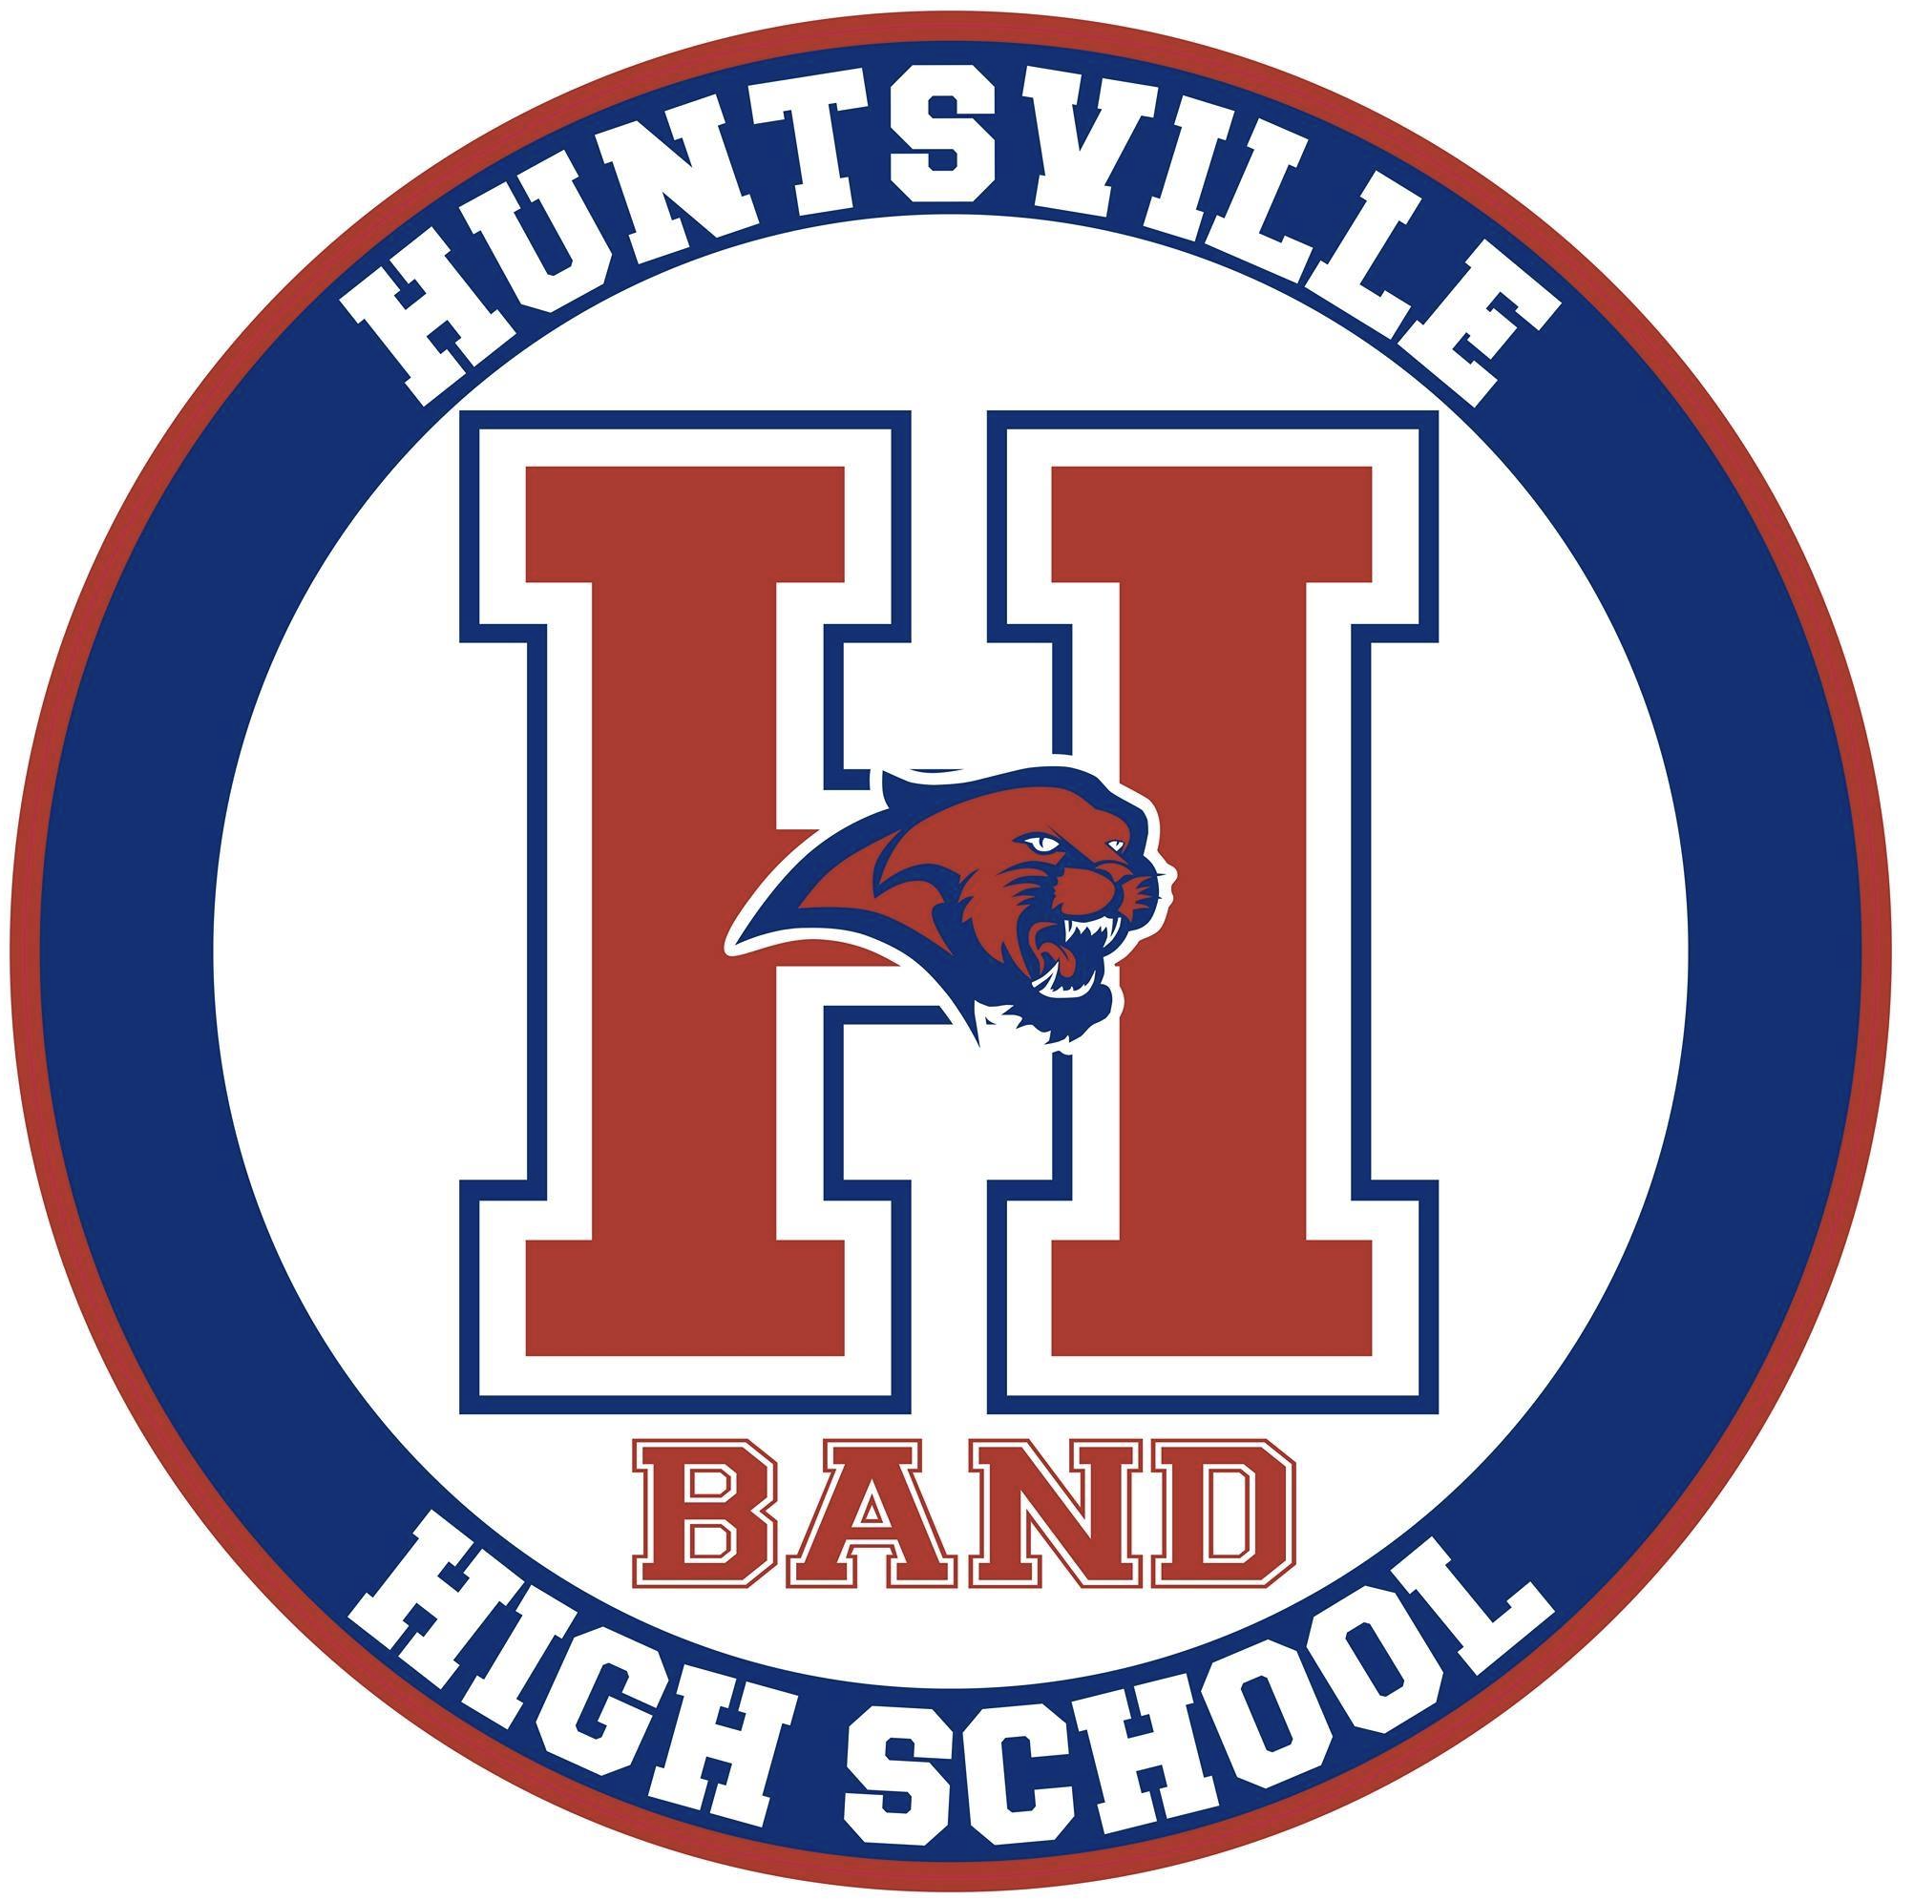
Huntsville High School Band Parent Association
Board Meeting Minutes
September 1, 2020
- Call to order
BPA President, Darin Miller brought the meeting to order by zoom call at 7:00 pm on Tuesday, October 13, 2020.
There were a total of 15 board and committee members present by zoom.
- Overview and general discussions
  - Darin Miller opened our meeting and asked if there were any questions or corrections to the posted board minutes from the last 2 meetings. Being that there were none the minutes were approved as written.
  - Stuart Tankesley thanked everyone for all that they do to support the band. He announced that we could now have chaperones when needed. They are going to start handing out concert uniforms this week. When school welcomes everyone back on October 26th they will not be required to have the band room set up with everyone 6’ apart. They will still be cautious and following procedures that are expected. For Spring All State auditions may be done online. MPA may also be virtual. On October 26th there will be the opening of a park near the downtown library that the band has been asked to play for. Planning for wind ensemble to play at this. More information to come. He asked if the charms calendar could be updated and Kelly Hudson, the BPA secretary, will do this.
  - Darin Miller asked if there might be a member who is willing to make the ask of the school board about using the school for our mattress fundraiser. We do not have approval at this time and it might be better coming from a parent. Sheri Polzin asked a few questions on this. Can the event be on a Saturday vs. Sunday? We also heard from Charlie with the fundraising company on different options. We talked about February 27th as a possible alternate date. Mrs. Connell asked if we might consider combining events with Grissom band that is holding theirs at a church. Someone mentioned the empty showroom at Damson Honda. Check with Ben Boles on this. If we don’t have a location by this Sunday we should move to the spring. Darrin is also going to check on the Knights of Columbus building.
  - .Elena Barbre gave us an update on fundraising. Had to cancel Boston butt fundraiser for now. Looking for an alternate company for this. We may have the sheets fundraiser in December. Darrin said that we should move forward with that. Is anyone interested in having a silent auction? Does it make sense to do something like this right now? Would like to continue with selling spirit gear. May want to discuss more products. Check in with First Stop in Hampton Cove on options.
  - Darrin Miller asked if someone would be willing to work on a brochure for the fall concert. Kim Ejide volunteered to make this.
  - Darrin Miller presented information about checks & balances we should have in place for the band association. He has looked in to a bond through State Farm & CMI. The option that was voted on was 200,000 for 4 people at the cost of $347 per year. There was a motion by Brenda Tapia and seconded by Kelly Hudson. The motioned passed.
  - Brenda Tapia our treasurer sent everyone a copy of the current budget numbers by email. At this point $23,000 has been brought in through student fees. There will be a reminder placed in the newsletter about student fees. We have a new P.O. Box for band mail. It is now: 6585 Hwy. 431 s. Suite E #466, Hampton Cove, AL 35763
  - Bonnie Eversole discussed band uniforms going out. Do we want to have photos taken in the concert uniform? Let us talk through this, it may be possible. If we do concert uniforms it will include a lot more students. Bonnie will contact Life Touch. Someone asked about what the color guard would wear. Some ideas around this. Mrs. Connell mentioned that there would be a local winter guard competition.
  - Sheri Polzin, VBC liaison mentioned that she has reached out to the VBC but has not heard back from them.
  - Kirk Wimsett mentioned that there will be a little maintenance on the trucks this season.
  - Darrin Miller thanked everyone for a fantastic Senior Night. Christy Rainey did a great job and mentioned that we did not go over budget.
  - New Business: Mrs. Connell discussed the need for additional music stands. They will cost around $60 each. We discussed different ideas about how to raise funds for this. A motion was made and voted upon favorably to move money form the Director dues & travel in the amount of $900 to cover this cost. We are gong to set up a paypal account to receive funds for those who want to contribute to this purchase so that we will not have a need to move these funds. Brenda Tapia is going to set up the paypal account. Ask Ben Boles about creating something to post. Also discussed setting up an Amazon smile account.
- Adjournment
Meeting ended at 8:13 pm by BPA President, Darin Miller.

Minutes submitted by: Kelly J. Hudson
Minutes approved by: ____________________ Date:___________________________

